Three-Way Merge

What is Three-Way Merge in Version Control?
# Source: AI Source: Provided by: [Data Path: Persons Table -> ID Column: 1, Name_En Column: Motasem Essam] -> From: [ChatGPT] on [2/15/2026]
A three-way merge happens when two branches have diverged — that is, both branches have commits that the other branch does not have.
Git then uses a three-way comparison to combine the changes and create a new merge commit.

How it works
# Source: AI Source: Provided by: [Data Path: Persons Table -> ID Column: 1, Name_En Column: Motasem Essam] -> From: [ChatGPT] on [2/15/2026]
Git looks at three points:
- Common ancestor → the last commit both branches share
- Current branch (HEAD) → your branch you’re on
- Other branch → the branch you’re merging
Git compares changes from both branches relative to the common ancestor to figure out what to include in the new merge commit.

Example
# Source: AI Source: Provided by: [Data Path: Persons Table -> ID Column: 1, Name_En Column: Motasem Essam] -> From: [ChatGPT] on [2/15/2026]
Suppose we have:
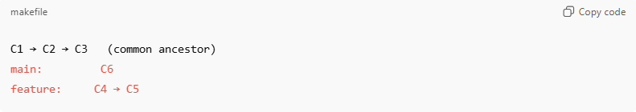
C1 → C2 → C3 (common ancestor)
main: C6
feature: C4 → C5
- main has commit C6
- feature has commits C4 and C5
When you merge feature into main:
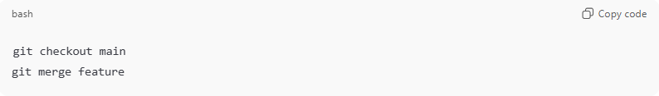
git checkout main
git merge feature
Git creates a new merge commit M:
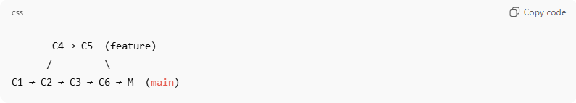
C4 → C5 (feature)
/ \
C1 → C2 → C3 → C6 → M (main)
- Merge commit M has two parents: C6 (main) and C5 (feature)
- It stores a snapshot combining changes from both branches
- If both branches changed the same lines, a merge conflict occurs that you resolve manually

Key Points
# Source: AI Source: Provided by: [Data Path: Persons Table -> ID Column: 1, Name_En Column: Motasem Essam] -> From: [ChatGPT] on [2/15/2026]
- Needed when branches have diverged
- Creates a merge commit → preserves branch history
- Uses the common ancestor as the base for combining changes
- May require manual conflict resolution

Fast-Forward vs Three-Way Merge
# Source: AI Source: Provided by: [Data Path: Persons Table -> ID Column: 1, Name_En Column: Motasem Essam] -> From: [ChatGPT] on [2/15/2026]
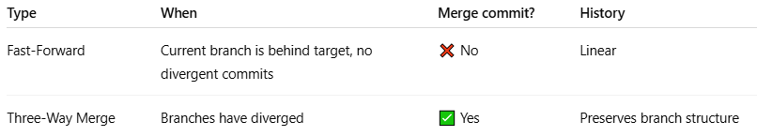
Type | When | Merge commit? | History
Fast-Forward | Current branch is behind target, no divergent commits | ❌ No | Linear
Three-Way Merge | Branches have diverged | ✅ Yes | Preserves branch structure

Analogy
# Source: AI Source: Provided by: [Data Path: Persons Table -> ID Column: 1, Name_En Column: Motasem Essam] -> From: [ChatGPT] on [2/15/2026]
- Branches = roads that split at a fork
- Common ancestor = the fork
- Three-way merge = building a bridge to combine the two roads back into one
- Merge commit = the point where roads meet again

💡 Memory trick:
# Source: AI Source: Provided by: [Data Path: Persons Table -> ID Column: 1, Name_En Column: Motasem Essam] -> From: [ChatGPT] on [2/15/2026]
Three-way merge = combine two diverged branches using their last shared commit as reference → new merge commit created ✅

